**How to create a Virtual Machine on Azure Portal?**

**Step 1:** **Visit Azure Portal, and make sure you have an account either free account, student account or organization account and login**

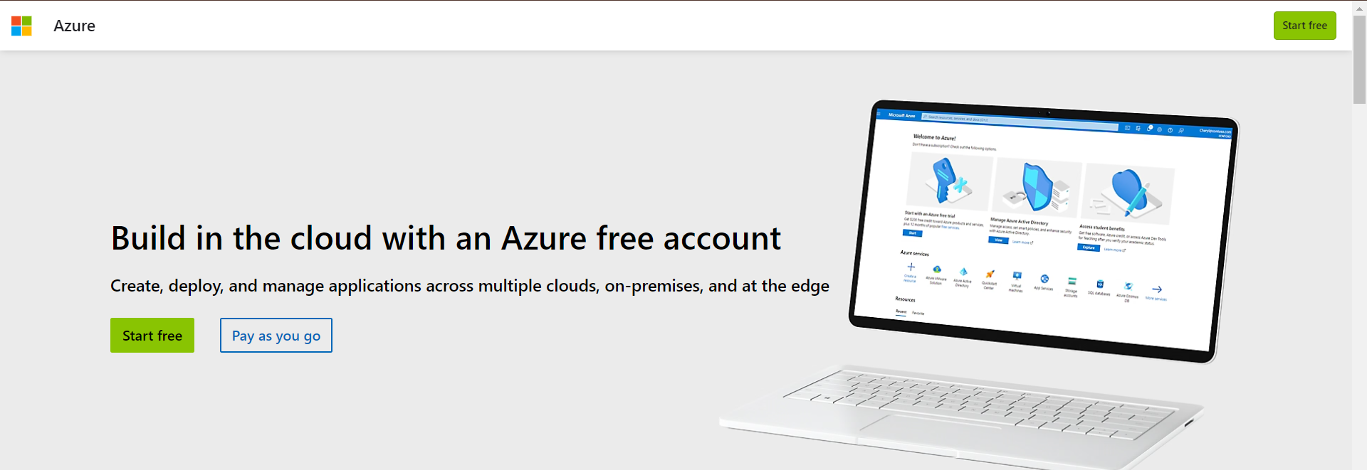

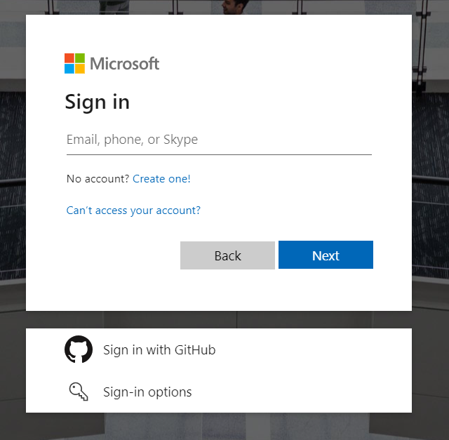

**After login with your details, below is how your azure dashboard looks like.**

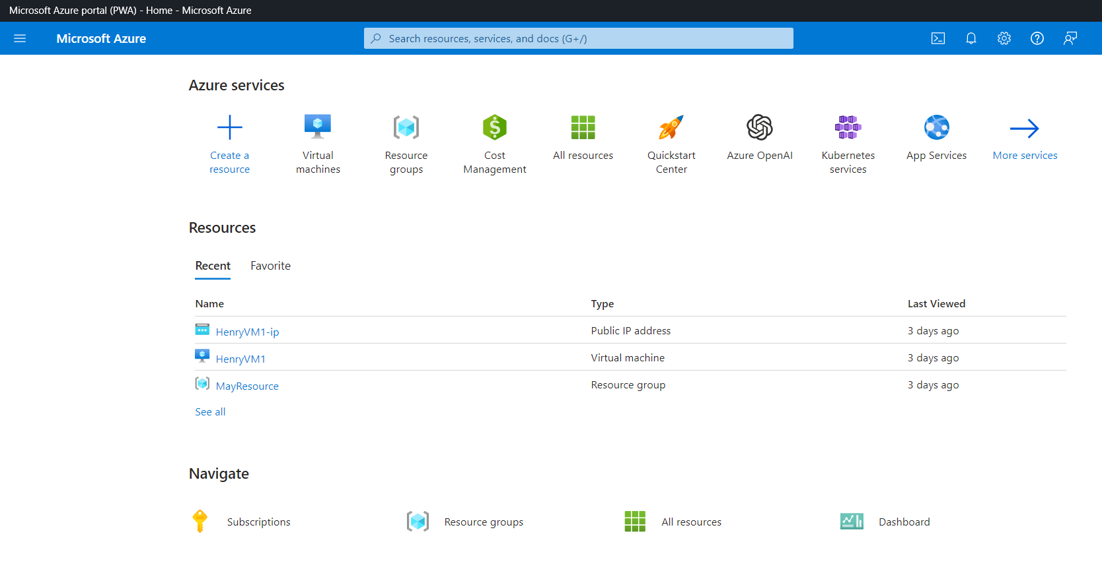  
  
**Step 2.** **There are different ways to create a virtual machine in Azure   
1. By searching on the search bar “Virtual machine”, select Virtual machines 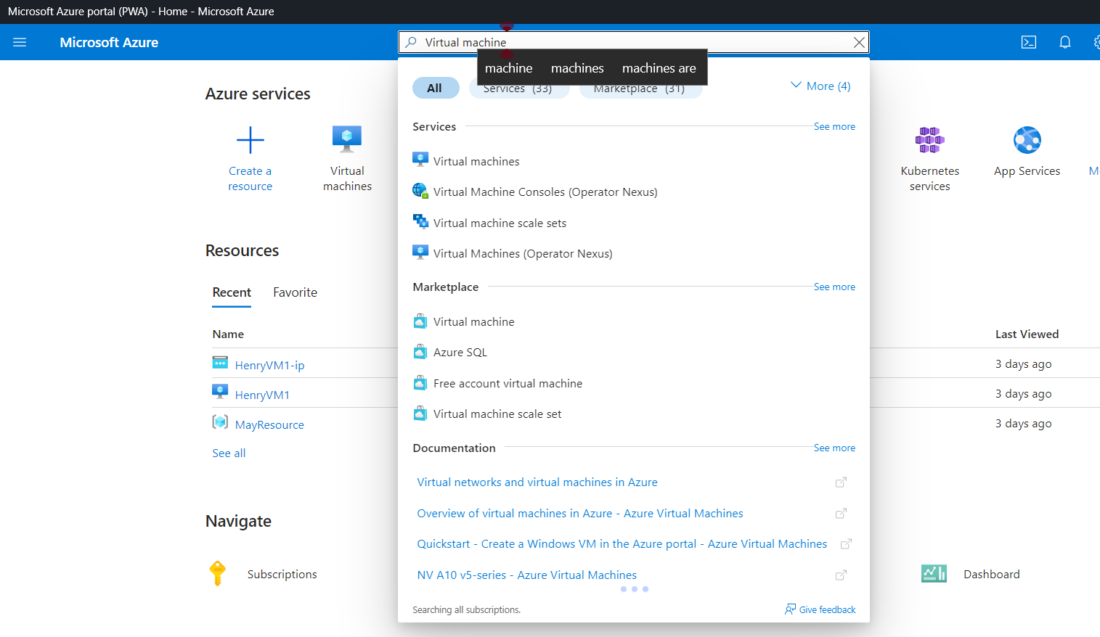Or   
From the Dashboard, Select “Virtual Machines” and click “Create”.  
Select Azure Virtual Machine ( if creating for the first time ) or “Azure Virtual Machine with present configuration if you already have established a configuration before.**



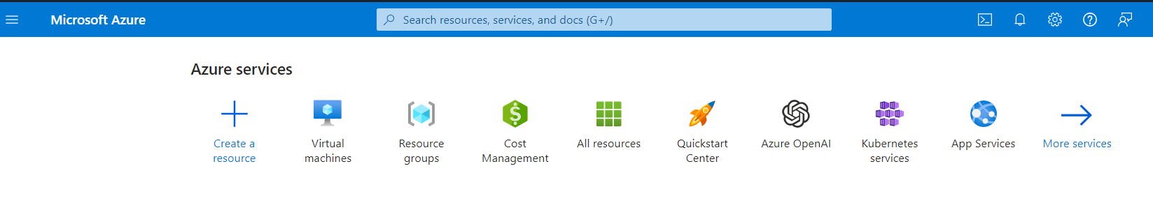



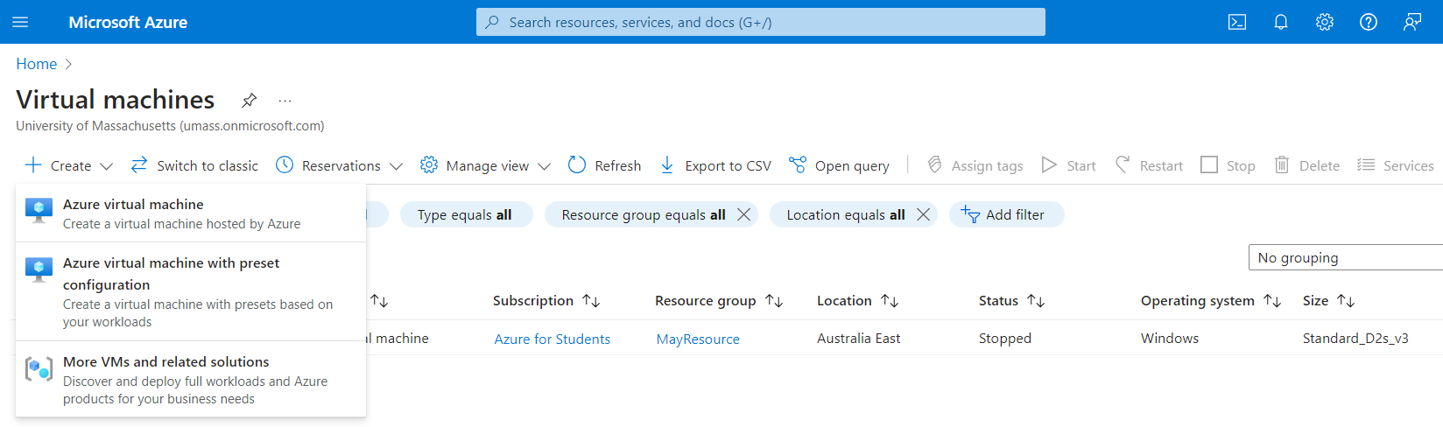



**Step 3**. **On the create page, under the “Project Details”   
1. Select your subscription, if you have a free account, it will be selected as default, if its organization, select your organization subscription.  
2. Select a resource group, if you don’t have a resource group, “Create new”.**

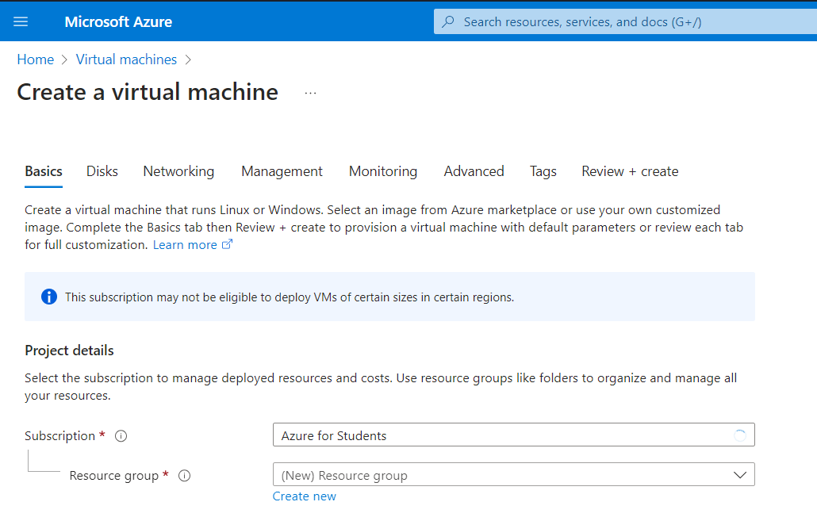



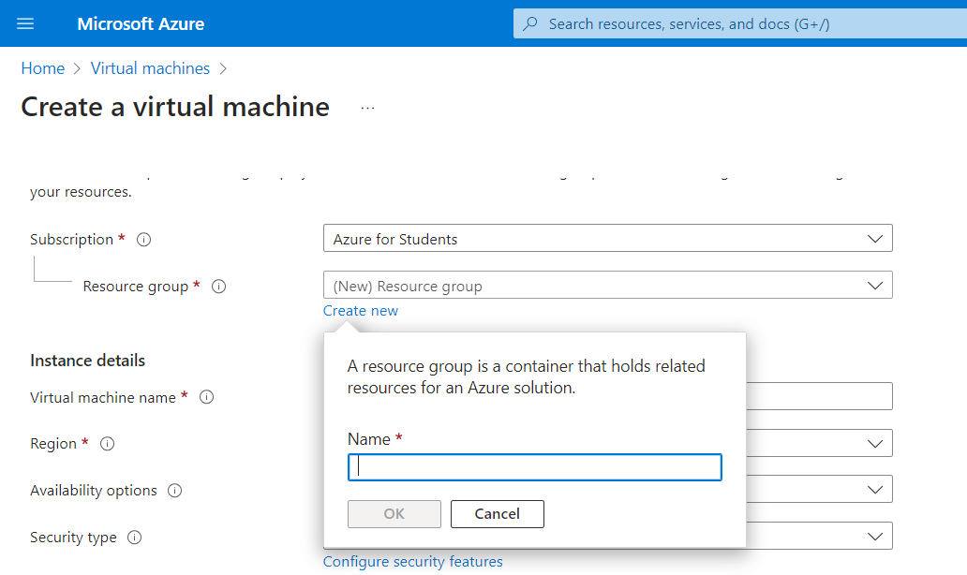



3. After Creating a resource group, click ok

**Step 4: Instance Details section, Under this,**

**1. Name your Virtual Machine,   
2. Select a region where you want your VM to be supplied  
3. Select an availability option, this enable you have multiple zones where your VM can be deployed  
4. Select the “Image”, in this case this is the type of Computer you want as a VM, select any of your choice, (Windows, 10, Windows 10pro Ubuntu, etc)**

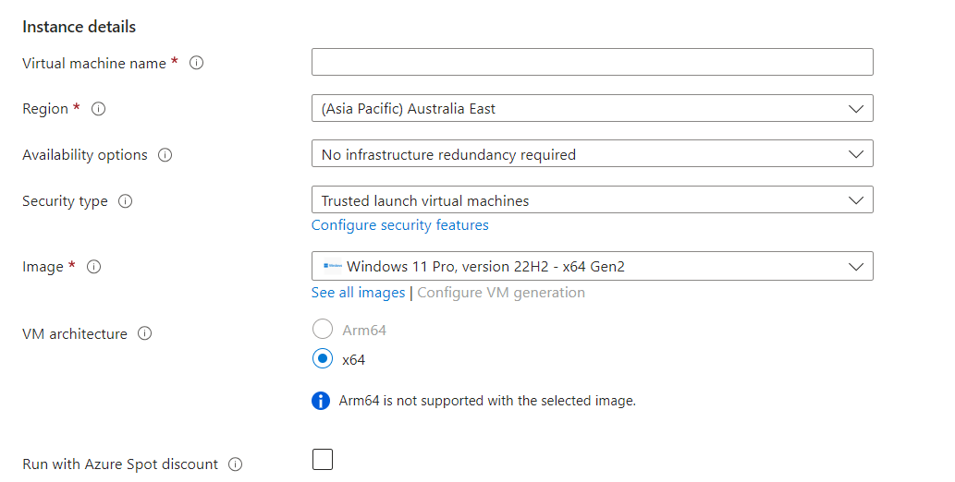



**Step 5**: **Administrator Account – This is the Username and password for your VM, whenever you want to access your VM (Which in order words, a Virtual Computer).**

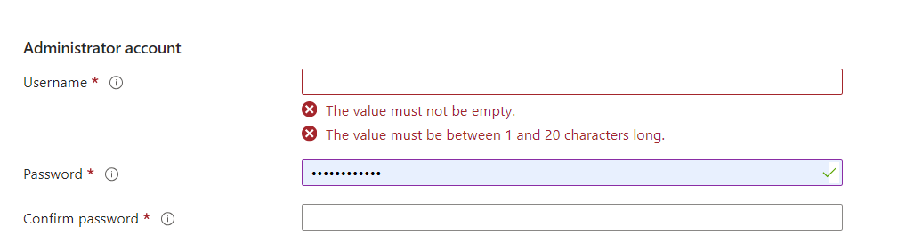

**Step 6: Inbound port rules, check “Allow selected ports” to create multiple ports to access your VM.**

**Then Under Licensing, “Check the Box to confirm eligibility windows you choose”.**

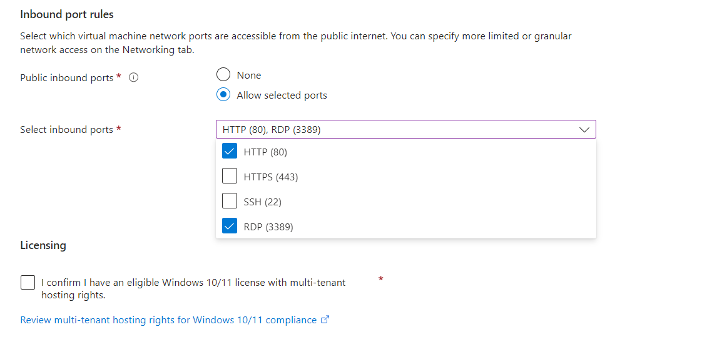



**Step 7**: **Next Click on “Monitoring Tab”**

1. **You are enable alerts for your VM, to get report or updates on your resource**
2. **Under diagnostic, you can enable with storage, depends on the purpose of your VM**

**But for this VM, I will disable Boot diagnostic, because this is just a sample process to create a VM..**

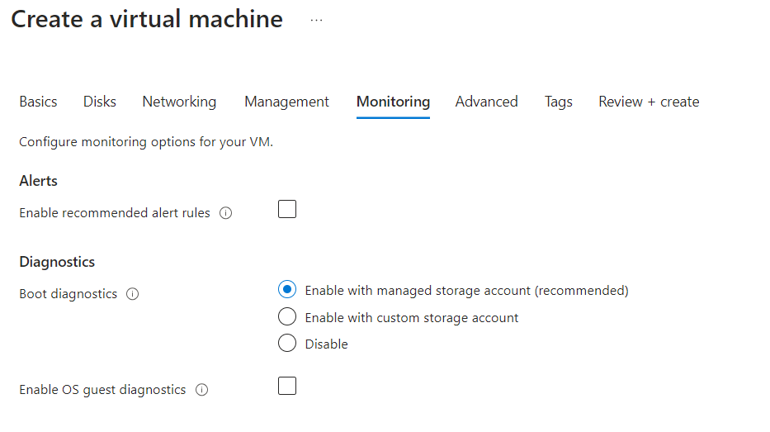



**Step 8**. **Networking, Click on the Networking Tab and create a Network for the VM for it to be accessible,   
1. Select the default address space and Subnets, then click “Ok”.**

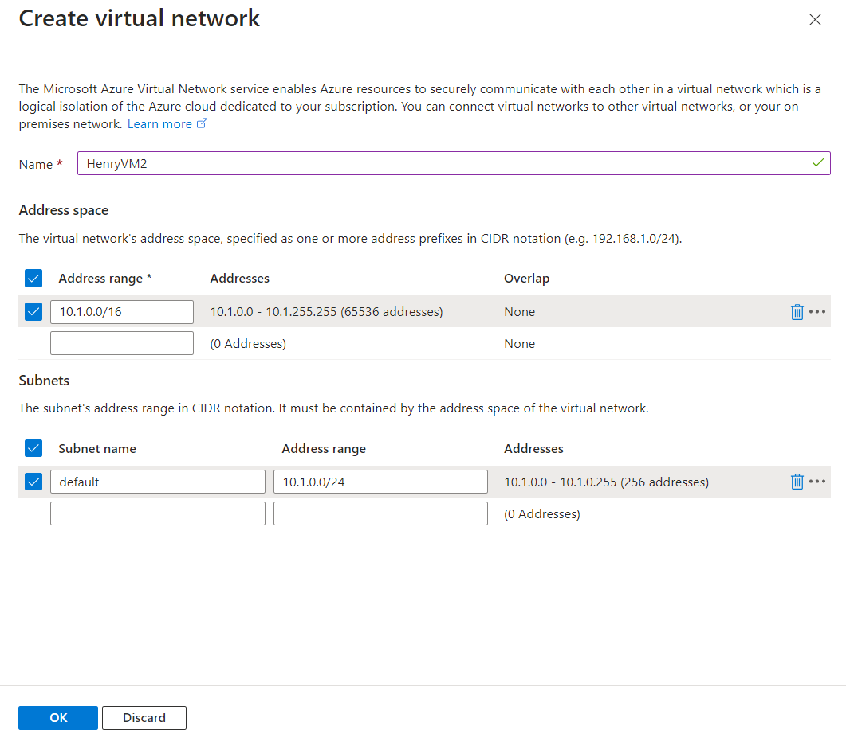



**Step 9**. **Tag Tab, Create a “Tag” for your VM**.

**Then Click Review and Create**

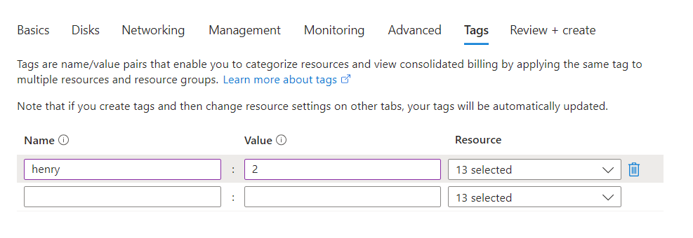



**After Review and create, the below screen will pop up, to indicate “Validation passed”, then click “Create**”.

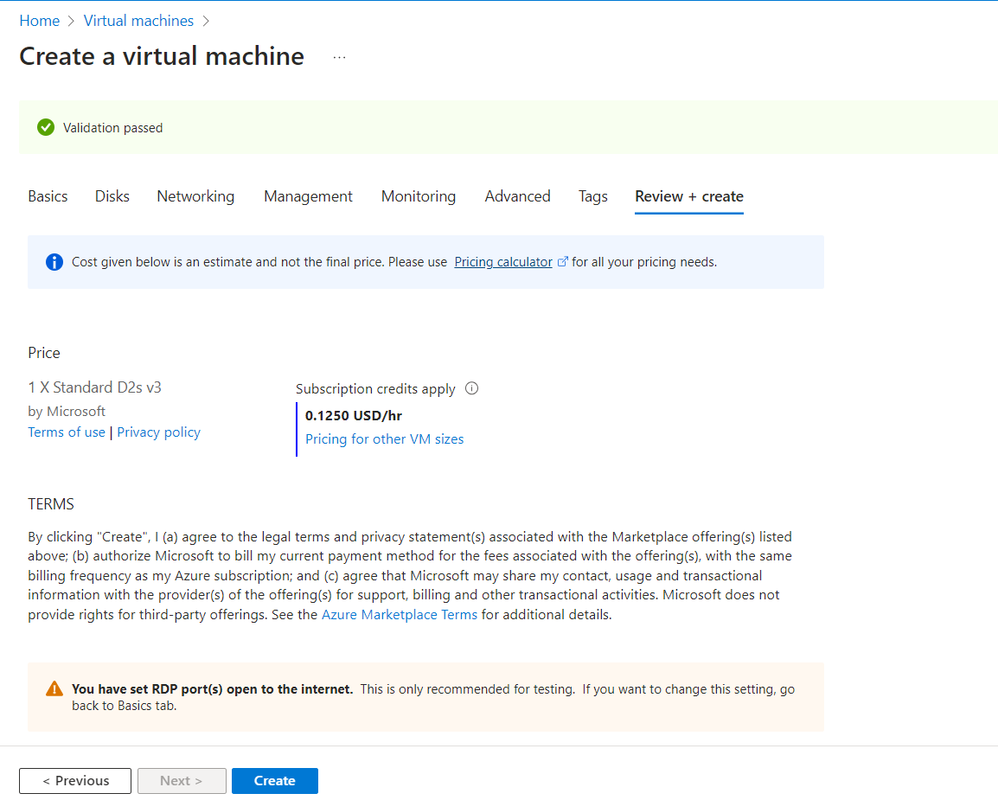



**After Creating your VM, the next stage is “Deployment in progress”.**

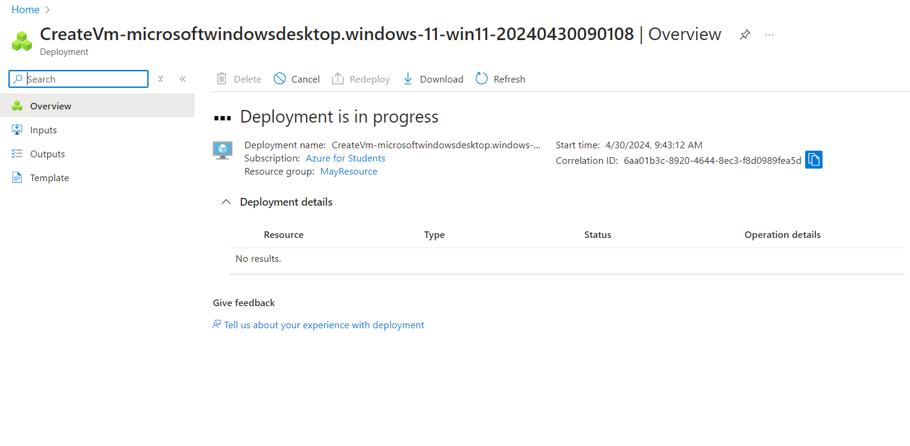



**Once your VM is deployed, the next notification is “Your deployment is complete”  
  
Congratulations, you have successfully created a VM on Azure portal.  
Then click on “Go to resource”, because this VM is a resource, in order to access it we need to go resource page.**

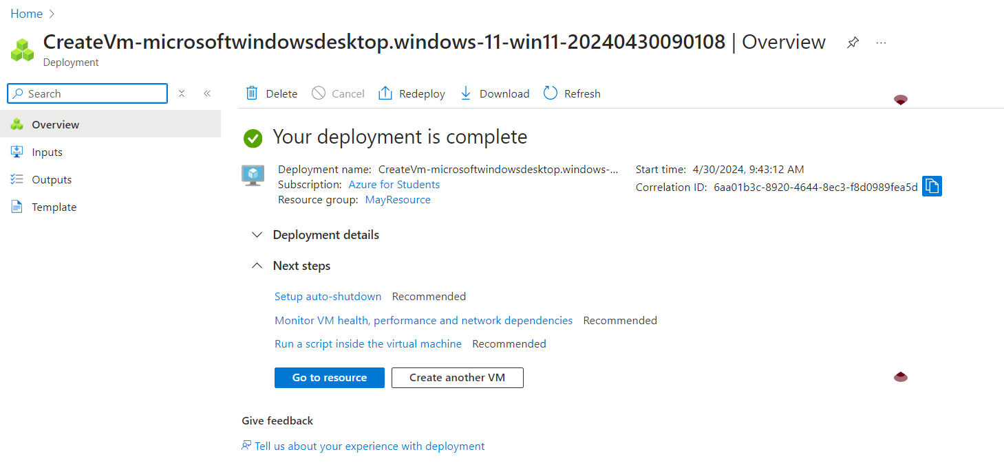



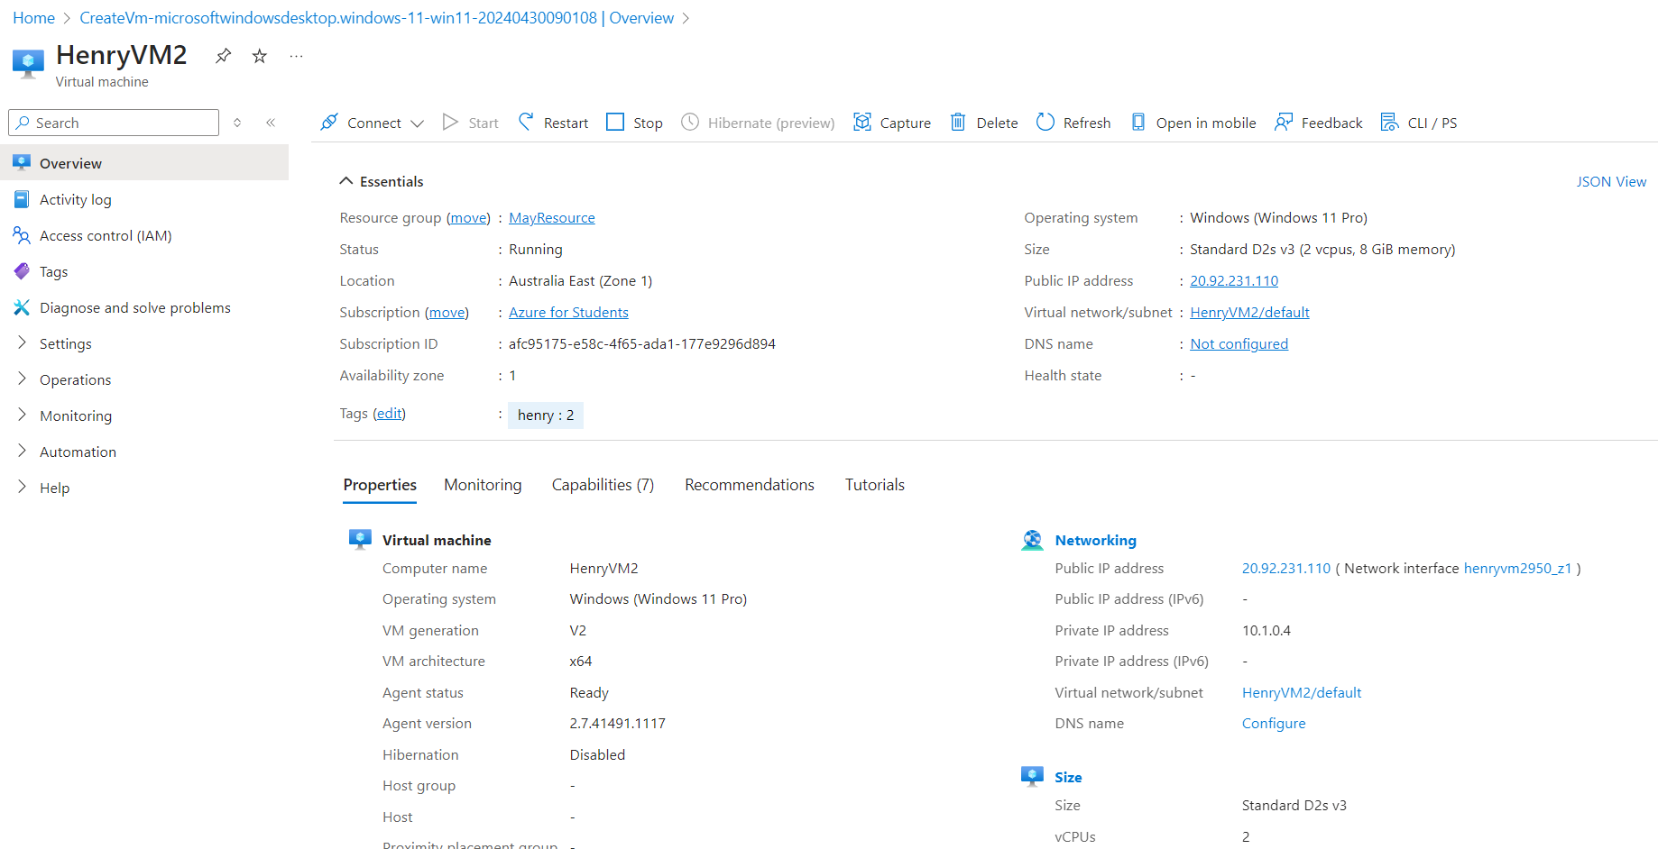



**Above is our VM resource page   
  
Step 10: Click on “Connect” to access connect to our VM.   
  
1. On the VM connect screen, we can see ( the public IP address for the VM , Name and other details)   
2. There are other ways to connect to VM, but for this “Select” Native RDP Local Machine”.**

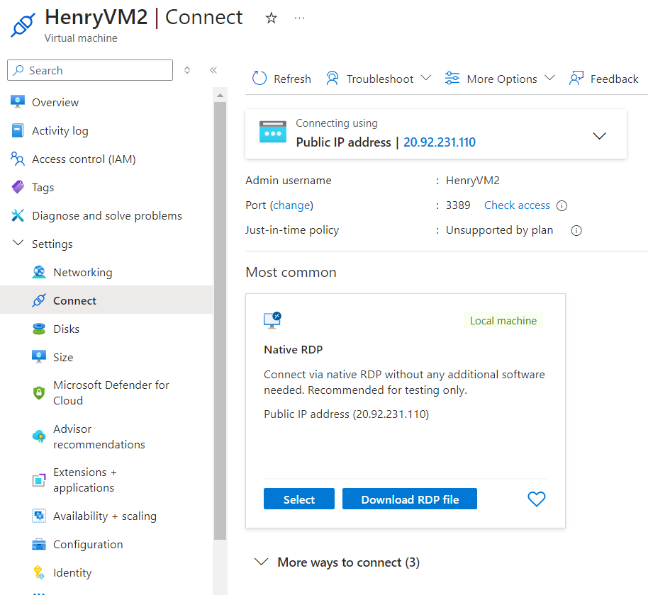



1. **Wait until the Public IP Address has been configured.**

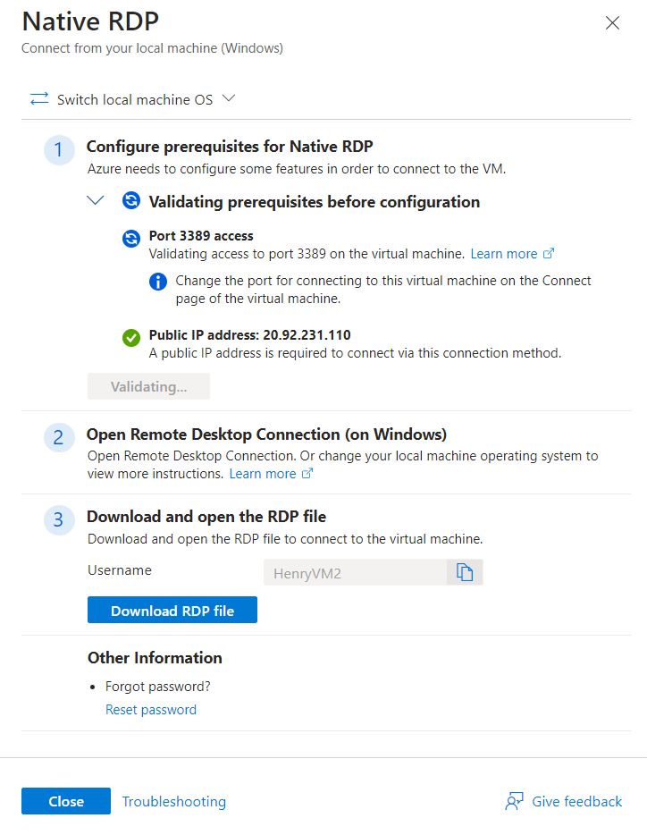



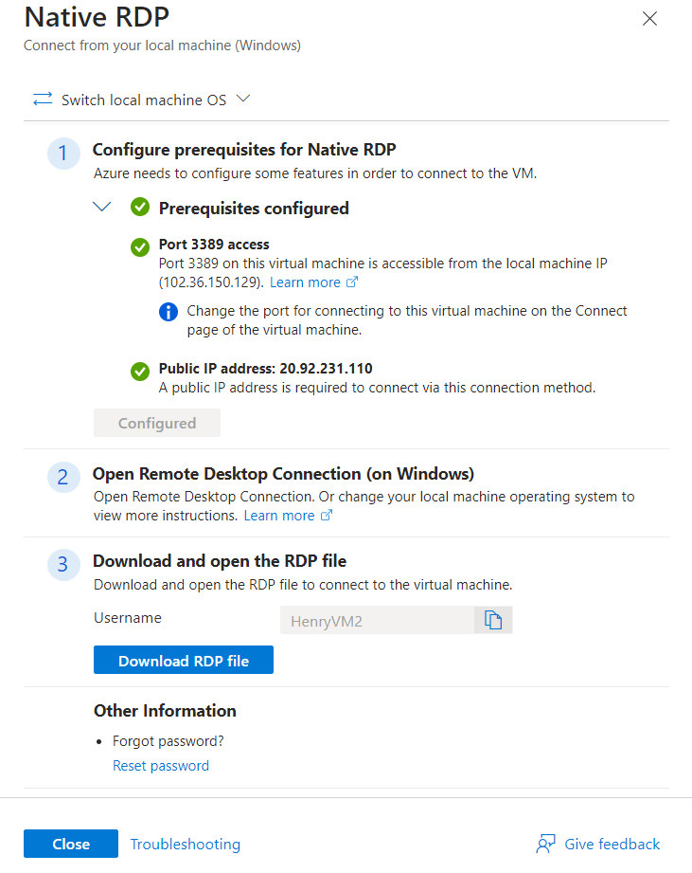



**After configuration, Close the page and Download the RDP FILE**

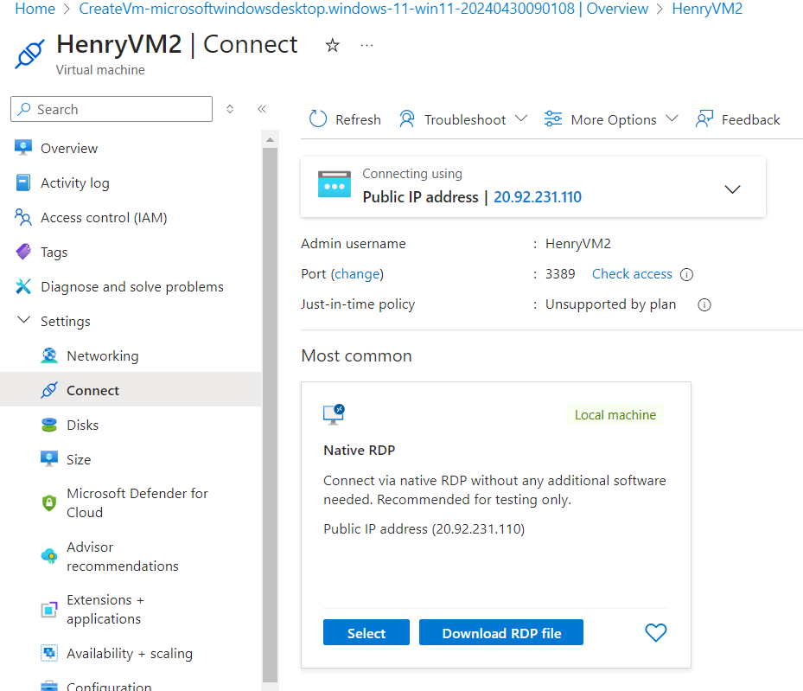



**Step 11. Download the RDP FILE and open it  
1. Connect to the remote DESKTOP connection**

**2. Enter the password we gave the VM at the beginning**

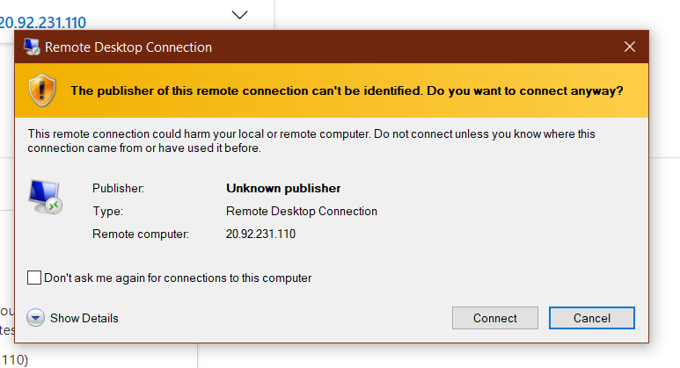

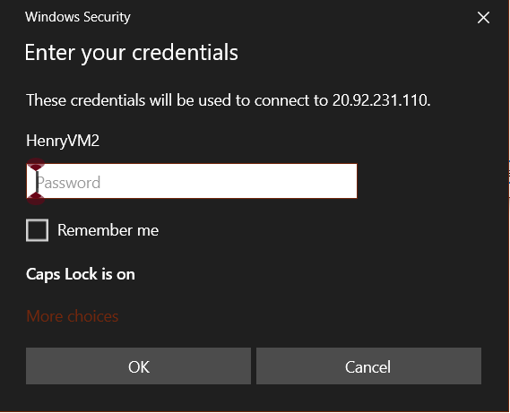

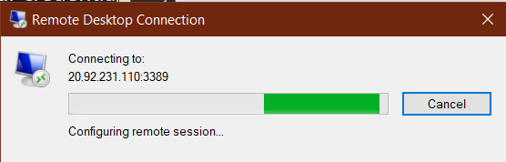

**Congratulations, you have created your first VM in Azure.** 